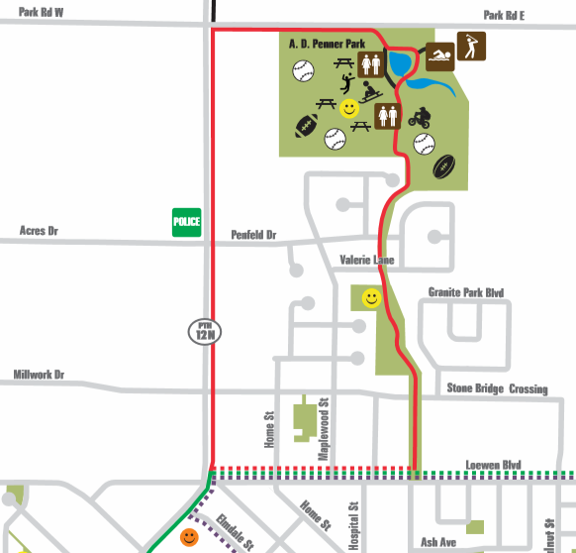
4
START/END
TURN AROUND
POINT
3 KM

